**'Jet' Chassis Construction**

This guide describes how to construct the 'Jet' chassis using the Actobotics chassis parts. These instructions are used for both the Jetson TX1 and TK1 versions of Jet.

# Chassis Frame

NOTE: for this procedure you will use the 7/64 hex wrench included with your kit, as shown here.

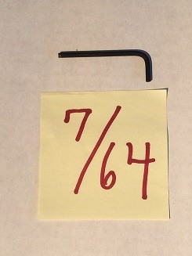

1. Locate the Actobotics component 'dual mount A' along with four 6-32x1/4" screws.

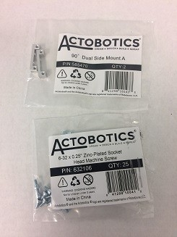

1. Attach the 'dual mount A' into the end of a 12" Actobotics channel. The mount should sit flush with the end of the channel.

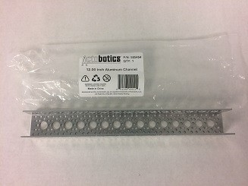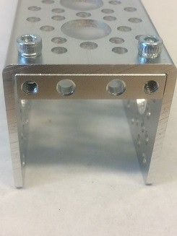

1. Turn the channel on its side and attach the channel to another 12" channel. One channel should be open to the side and the other channel should be open downward.

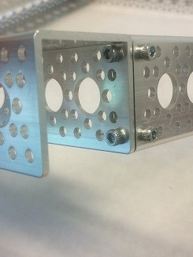

1. Repeat with another 12" channel to obtain a U-shaped structure. Two of the channel pieces should be open to the center.

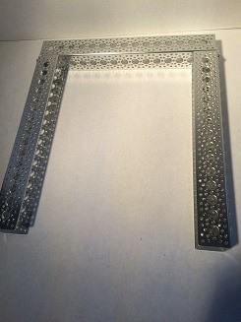

1. Locate the quad pillow block along with four 6-32x1/4" screws.

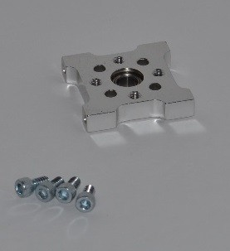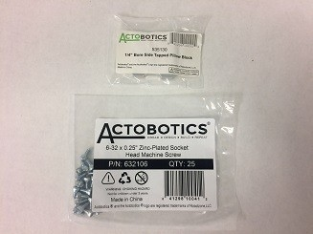

1. Attach the quad pillow block to the center of a 12" channel. This quad pillow block will be the lower bearing for the caster wheels.

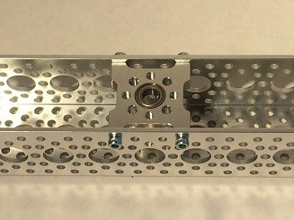

1. Attach the channel with the quad pillow block to the other three channels. This will complete the rectangular frame. The front of the robot will be the channel without the quad pillow block.

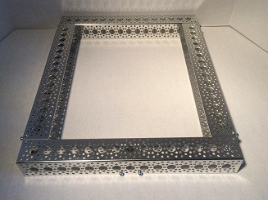

# Motors

* 1. For the motors, you will need the 50:1 12 gearmotor and the 37mm clamping motor mount.

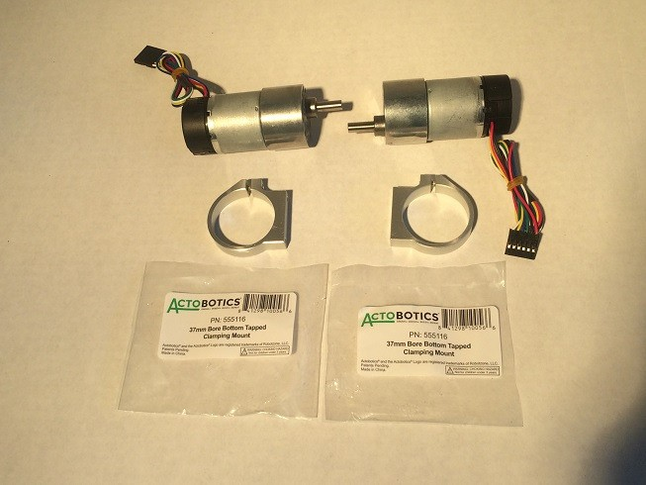

* 1. Secure the motor into the mount. Spin the motor in the mount so that the shaft is as close as possible to the flat part of the motor mount.

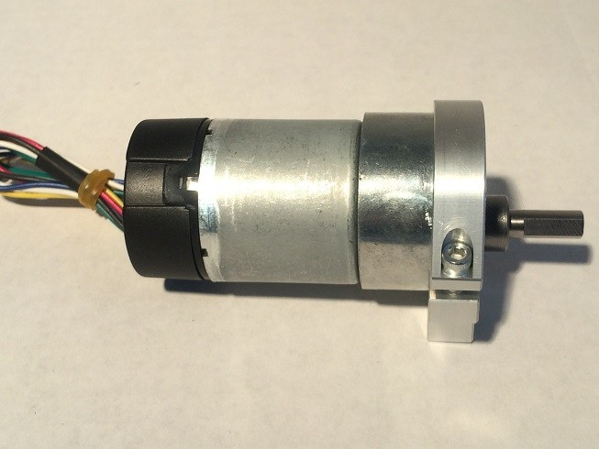

# Wheels

Perform this procedure for both wheels.

* + 1. Get the hub adaptor D and wheels.

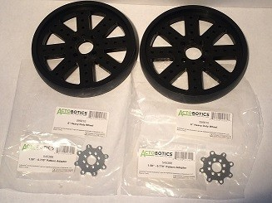

* + 1. Attach one hub adaptor D to each wheel.

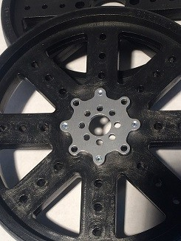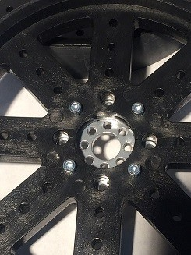

* + 1. Attach the clamping hub to the hub adaptor.

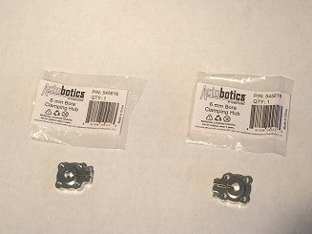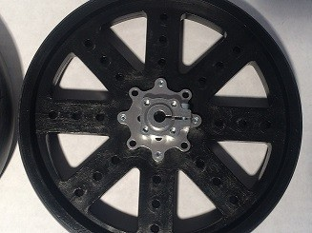

* + 1. Attach the motor shaft to the clamping hub.

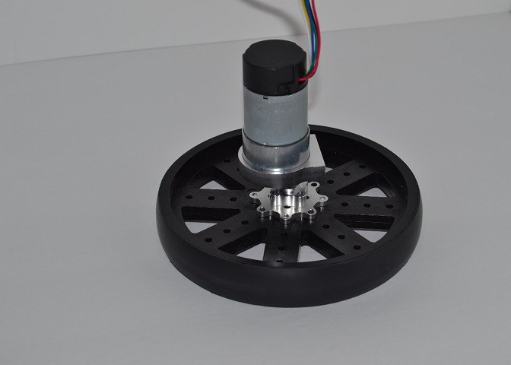

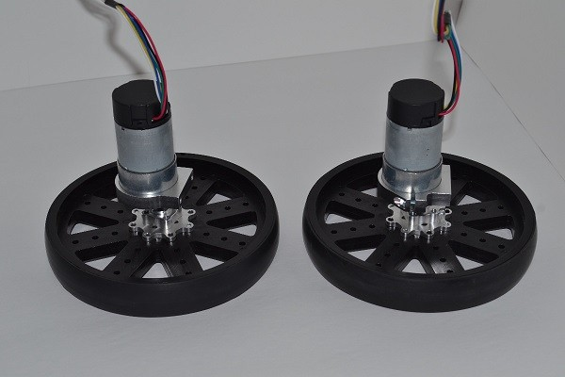8

# Caster Wheel

* + - 1. Connect the two 1/4" parallel tube clamps to the 1.5" channel as shown.

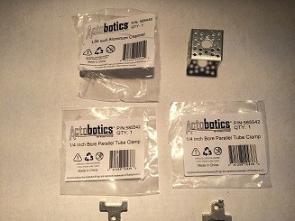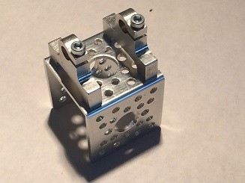

* + - 1. Connect 8mm flanged standoff A to the 1.5" channel. On each side, the standoff connects at the hole marked in red.

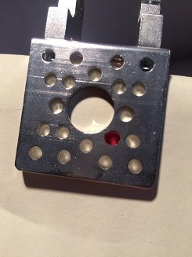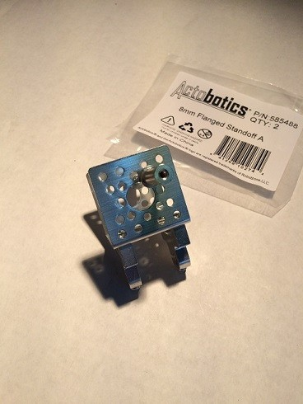

* + - 1. Secure the 5" shaft to the parallel tube clamps. Also install the 1/4" shaft clamp collar on the 1/4" shafting. The lip edge of the clamp collar should face up.

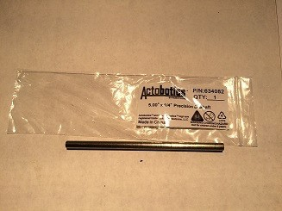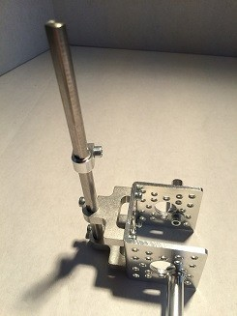

* + - 1. Install the skate wheels on to the standoffs.

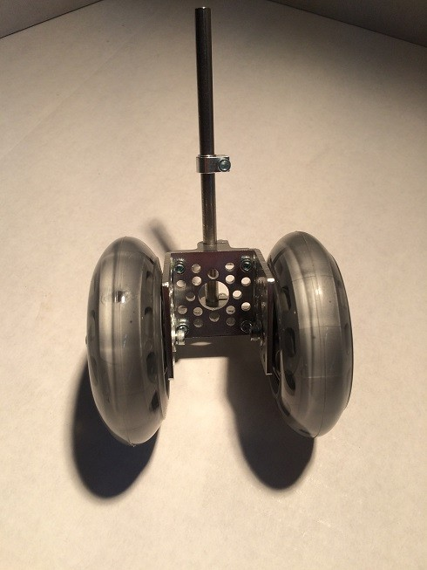

# Final Assembly

* + - * 1. Attach the motor mounts to the side channel of the frame.

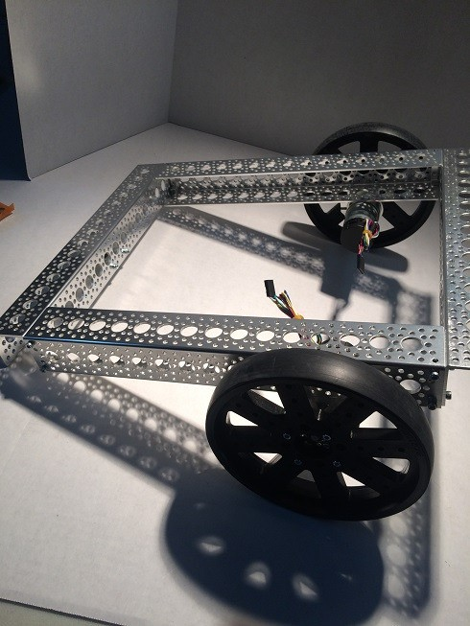

* + - * 1. Attach the caster to the frame. Use a flanged bearing as the top bearing and secure the caster with a 1/4" shaft clamping collar.

